Objective of This Lab
Implement Role-Based Access Control (RBAC) in Eramba and simulate:
- User onboarding
- Role-based access
- Least privilege
- Access review
- Remediation

STEP 1: Define Your Scenario (Before Touching the Tool)
Create your mock company:
Company: MaplePay Financial
Departments:
- SOC
- GRC
- IT
- HR
- Executive
Now define:
🔐 Control Objective
Ensure users only have access required for their job function.
This is your governance statement.

STEP 2: Create Users in Eramba
Go to:
System → Users
Create example users:
- soc.analyst@maplepay.com
- grc.analyst@maplepay.com
Assign them basic login access.
📌 Think like a company: Who needs what access?

PART 2 — Create Users
🔹 Navigation Path:
System → Users
Steps:
- Click System
- Click Users
- Click Add User
Fill in:
- Name
- Surname
- Email
- Password
- Status = Active
⚠️ Leave group empty for now (we'll assign later)
Click Save.
Repeat for:
- SOC Analyst
- GRC Analyst
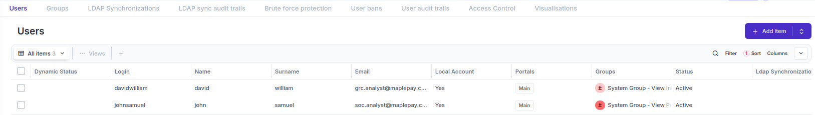

STEP 3: Create Groups (RBAC Model)
Go to:
System → Groups
Create groups:
- SOC_Team
- GRC_Team
This represents role-based access control.
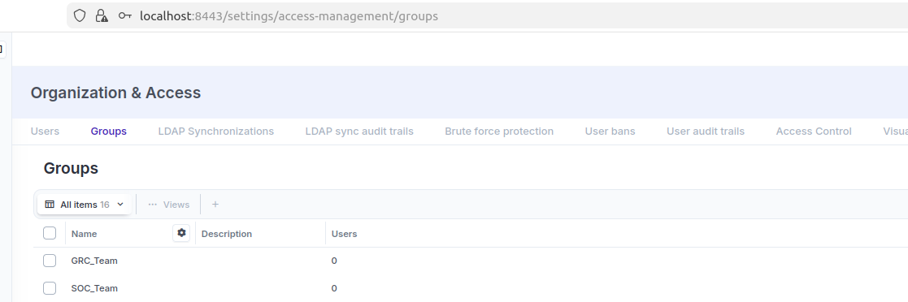
Now assign users to appropriate groups.

Assign Users to Groups
Still under:
System → Users
- Open a user (e.g., SOC Analyst)
- Click Edit
- In the Groups field
- Assign to SOC_Team
- Save
Repeat for all users.
Now your RBAC structure exists.

Example:
- soc.analyst → SOC_Team
- grc.analyst → GRC_Team
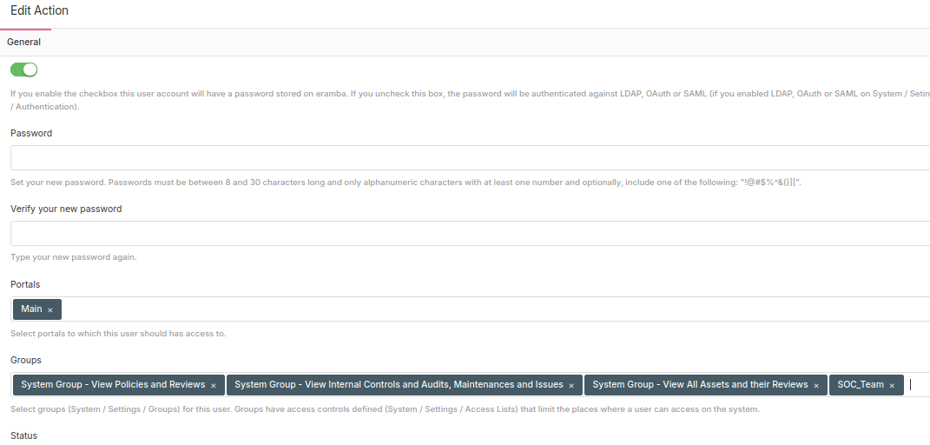
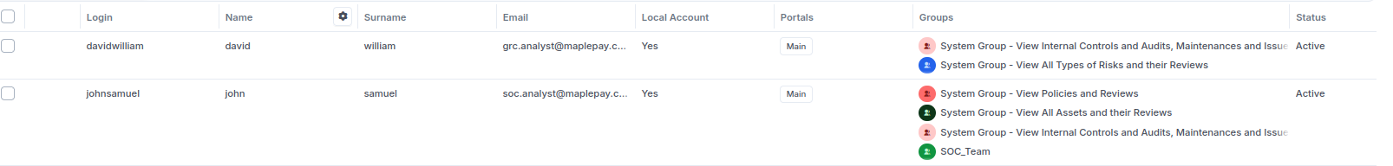

STEP 4: Configure Access Lists (ACLs)
Now the important part.
Go to:
System → Settings → Access Lists (ACLs)
Here you define:
- Which group can see which module
- Whether they can View / Edit / Delete / Admin

Example Configuration
SOC_Team
- Risk Module → View
- Compliance → View
- Security Incidents → Create/Edit
- Policies → View only
GRC_Team
- Risk → Full Access
- Compliance → Full Access
- Policies → Edit
- Security Incidents → View

Configure Access Lists (Critical Step)
🔹 Navigation Path:
System → Settings → Access Lists
This is where real access governance happens.

Understanding ACL Structure
Eramba access is controlled by:
- Module permissions
- Group-based privileges
- CRUD (Create, Read, Update, Delete)

Step-by-Step ACL Setup
- Go to System
- Click Settings
- Click Access Lists
- Click Add Access List
You will configure:
- Group
- Section (Module)
- Permission type
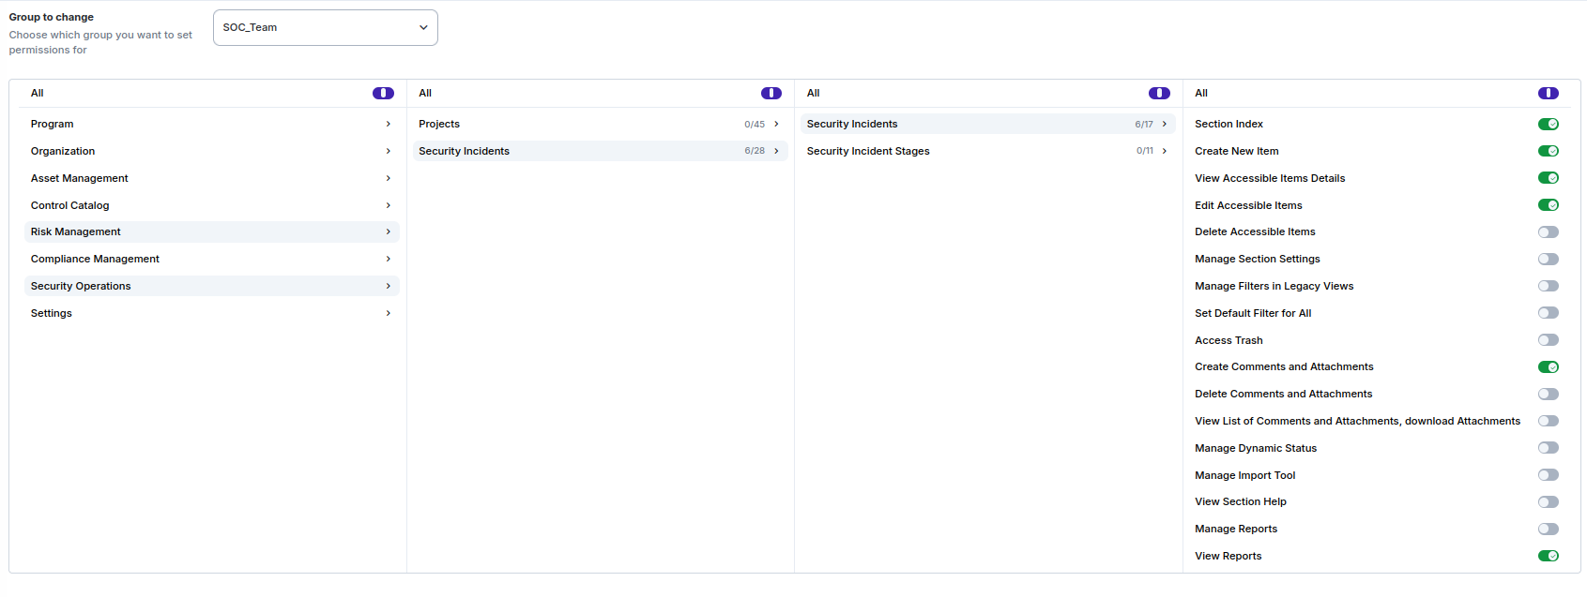

STEP 5: Validate Access (Testing Phase)
Now log in as:
- SOC user
- GRC user
- Executive user
Confirm:
- What they can see
- What they cannot edit
- What modules are hidden
📌 Take screenshots — these are portfolio assets.
I was able to create new incident item

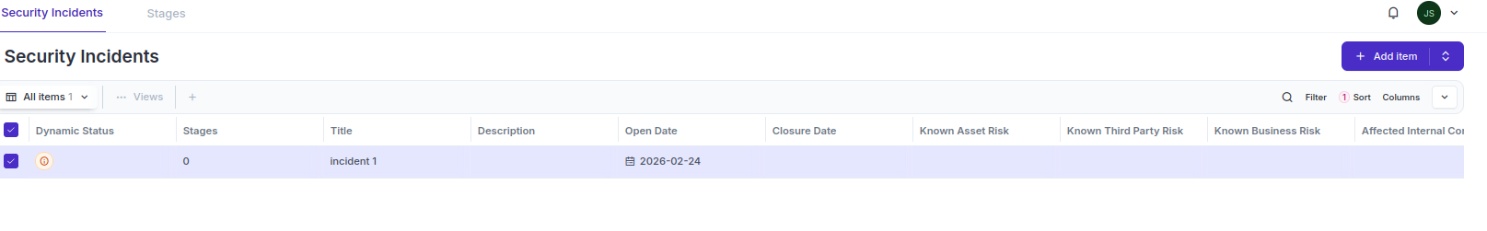

STEP 6: Simulate Access Review (Very Important)
Now simulate a quarterly review.
Scenario:
You will simulate:
- David was accidentally added to GRC Team
- John moved from SOC Team → GRC Team
- One user (choose David or John) is “terminated”

Perform:
- Review group memberships
- Remove excess access
- Document changes

Now you are performing:
- Access Certification
- Access Recertification
- Control Monitoring

STEP 1 — Go to Access Management
In Eramba CE 3.28.1:
Governance → Access Management → Groups Governance → Access Management → Accounts
These two sections are where the entire access review happens.
STEP 2 — Review Group Memberships (Access Certification)
You will manually inspect each group.
🔹 Group 1: GRC Team
- Go to: Governance → Access Management → Groups
- Click GRC Team
- Look at Group Members
Ask yourself:
- Should David be here?
- Should John be here?
If someone is incorrectly listed, you’ll fix it in the next step.
Group 2: SOC Team
- Open SOC Team
- Review members
This is where you simulate the “wrong access” scenario.
Example:
- David is incorrectly in GRC
- John should be moved to GRC
Perfect — now you can fix it.
STEP 3 — Fix Incorrect Access (Excess Access Removal)
🔹 Scenario 1 — David has wrong access (GRC Team)
- Open GRC Team
- Click Edit
- Remove David from the group
- Save
Add documentation:
Inside the same group → Comments:
“Quarterly Access Review: David removed from GRC Team due to excessive privileges. Reviewed and approved.”
This is your Access Certification evidence.
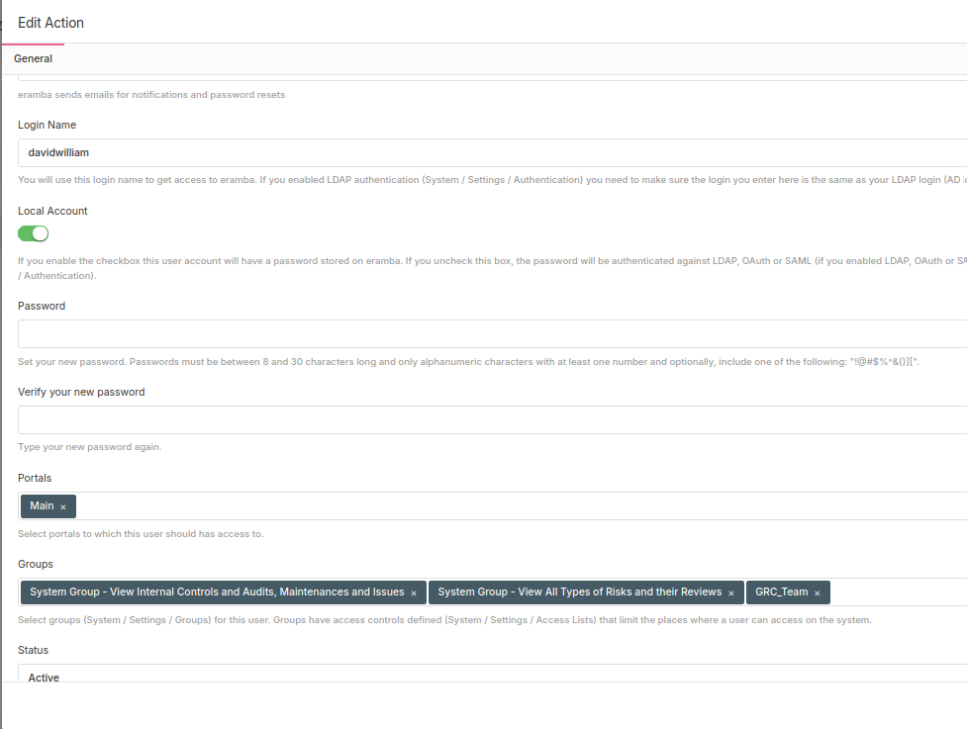
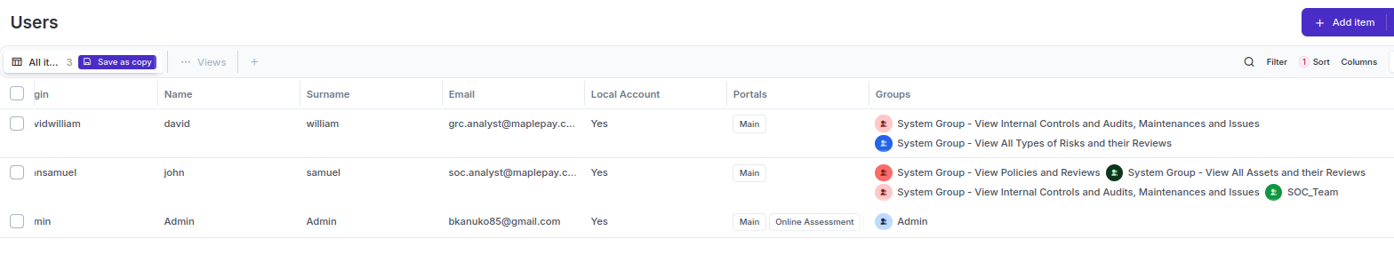
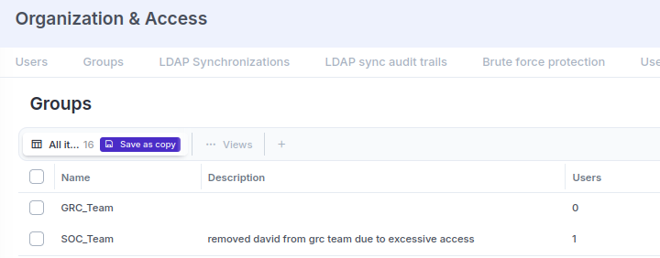
John is in soc should be moved to GRC
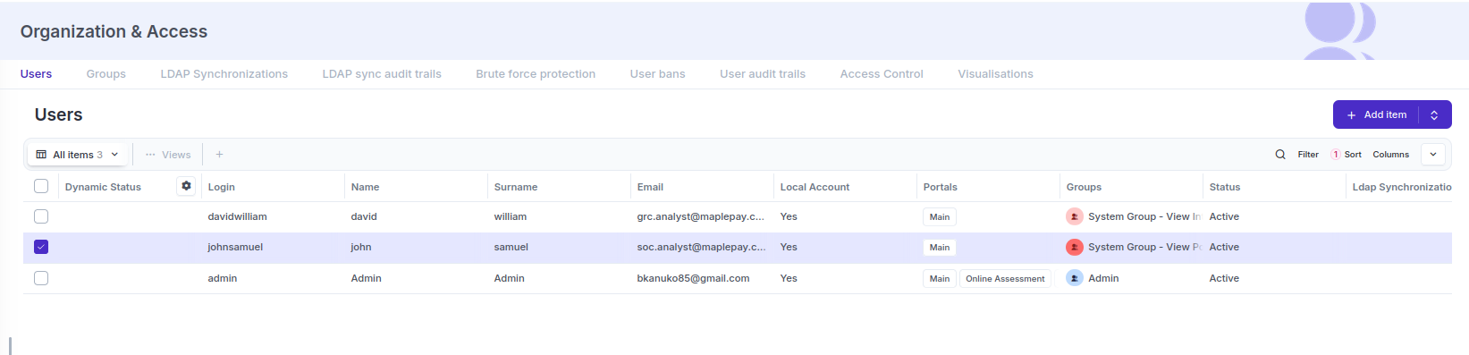
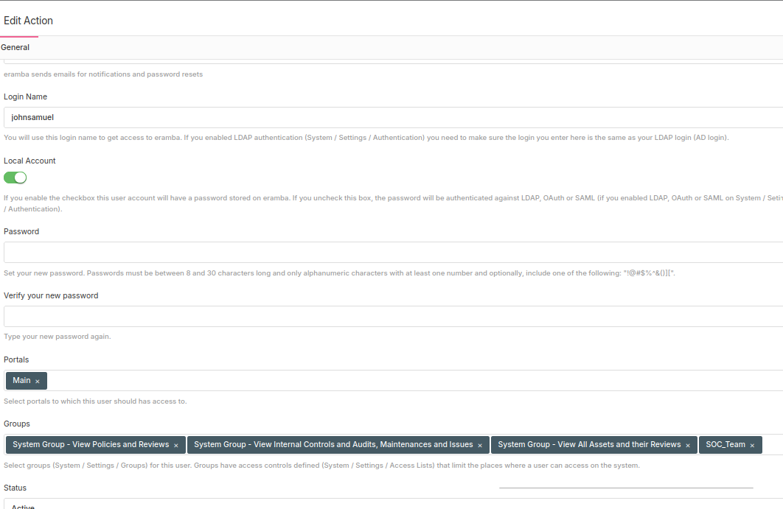
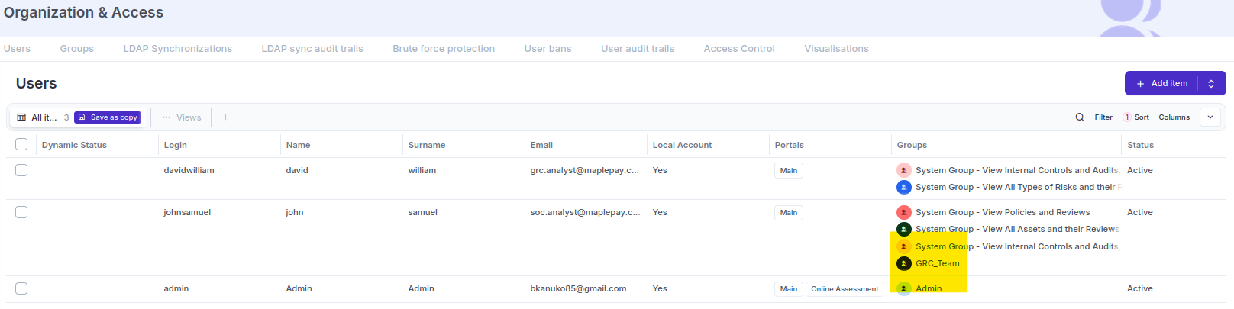
One user (choose David or John) is “terminated”
